C:\Users\NICOLE>python --version

Python 3.10.2

C:\Users\NICOLE>pip --version

pip 22.0.3 from C:\Users\NICOLE\AppData\Local\Programs\Python\Python310\lib\site-packages\pip (python 3.10)

C:\Users\NICOLE>mkvirtualenv py1

created virtual environment CPython3.10.2.final.0-64 in 29451ms

creator CPython3Windows(dest=C:\Users\NICOLE\Envs\py1, clear=False, no_vcs_ignore=False, global=False)

seeder FromAppData(download=False, pip=bundle, setuptools=bundle, wheel=bundle, via=copy, app_data_dir=C:\Users\NICOLE\AppData\Local\pypa\virtualenv)

added seed packages: pip==22.0.3, setuptools==60.6.0, wheel==0.37.1

activators BashActivator,BatchActivator,FishActivator,NushellActivator,PowerShellActivator,PythonActivator

(py1) C:\Users\NICOLE>workon py1

(py1) C:\Users\NICOLE>pip install django

Collecting django

Using cached Django-4.0.2-py3-none-any.whl (8.0 MB)

Collecting tzdata

Using cached tzdata-2021.5-py2.py3-none-any.whl (339 kB)

Collecting sqlparse>=0.2.2

Using cached sqlparse-0.4.2-py3-none-any.whl (42 kB)

Collecting asgiref<4,>=3.4.1

Using cached asgiref-3.5.0-py3-none-any.whl (22 kB)

Installing collected packages: tzdata, sqlparse, asgiref, django

Successfully installed asgiref-3.5.0 django-4.0.2 sqlparse-0.4.2 tzdata-2021.5

(py1) C:\Users\NICOLE>django-admin startproject groupffit

(py1) C:\Users\NICOLE>cd groupffit

(py1) C:\Users\NICOLE\groupffit>code .

(py1) C:\Users\NICOLE\groupffit>python manage.py runserver

Watching for file changes with StatReloader

Performing system checks...

System check identified no issues (0 silenced).

You have 18 unapplied migration(s). Your project may not work properly until you apply the migrations for app(s): admin, auth, contenttypes, sessions.

Run 'python manage.py migrate' to apply them.

February 09, 2022 - 09:55:03

Django version 4.0.2, using settings 'groupffit.settings'

Starting development server at http://127.0.0.1:8000/

Quit the server with CTRL-BREAK.

[09/Feb/2022 09:55:30] "GET / HTTP/1.1" 200 10697

[09/Feb/2022 09:55:30] "GET /static/admin/css/fonts.css HTTP/1.1" 200 423

[09/Feb/2022 09:55:30] "GET /static/admin/fonts/Roboto-Regular-webfont.woff HTTP/1.1" 200 85876

[09/Feb/2022 09:55:30] "GET /static/admin/fonts/Roboto-Bold-webfont.woff HTTP/1.1" 200 86184

[09/Feb/2022 09:55:30] "GET /static/admin/fonts/Roboto-Light-webfont.woff HTTP/1.1" 200 85692

Not Found: /favicon.ico

[09/Feb/2022 09:55:30] "GET /favicon.ico HTTP/1.1" 404 2113

Navigate to browser: localhost:8000

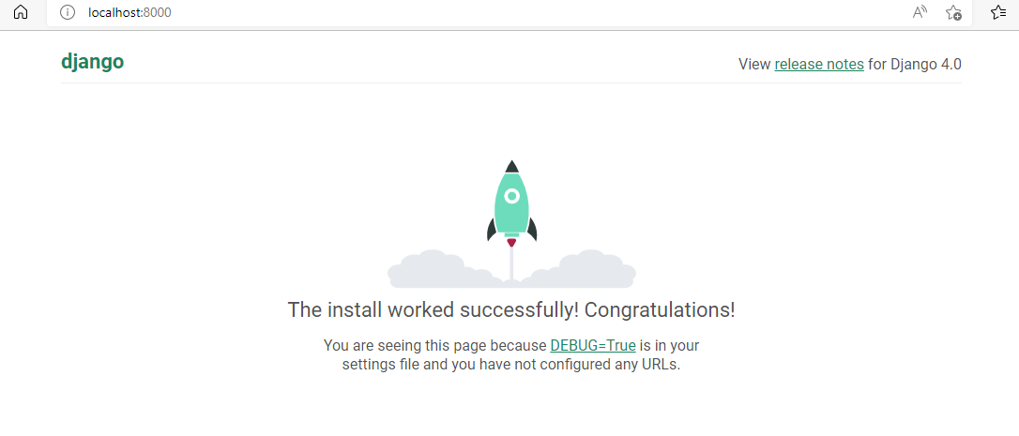

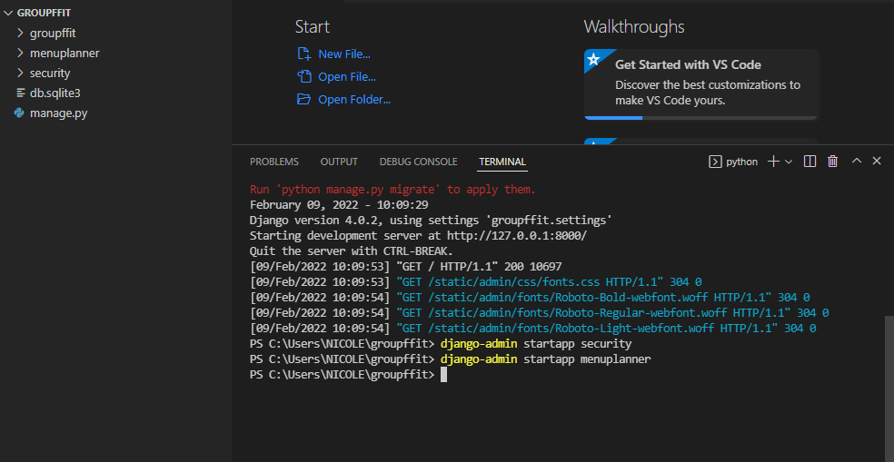

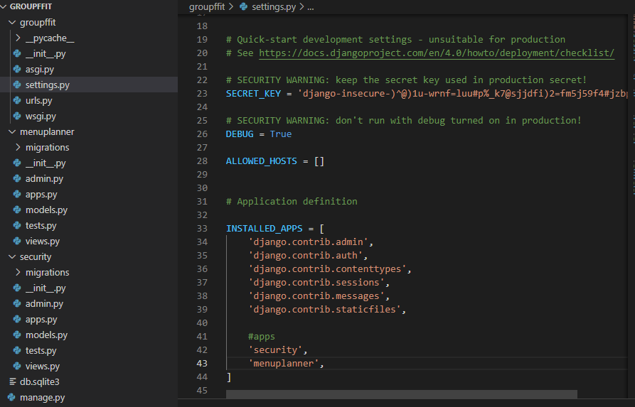

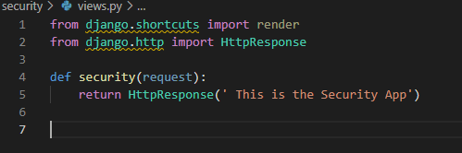

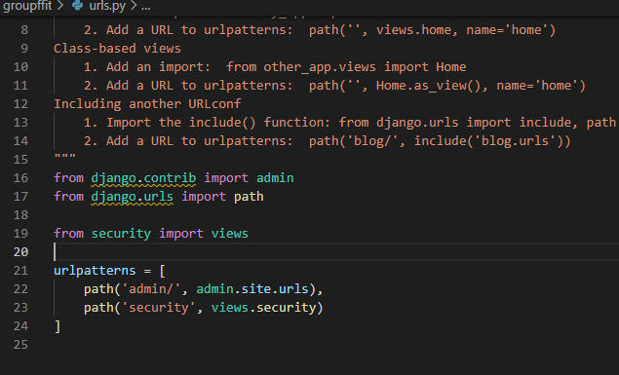

Save the security/views file and also the groupffit/urls.py

Rerun in Visual Studio Code terminal: python manage.py runserver

Navigate to the browser and type localhost:8000/security and press enter

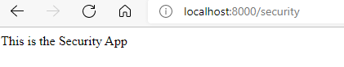

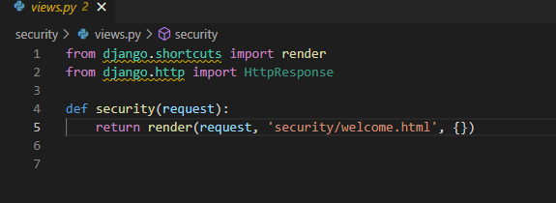

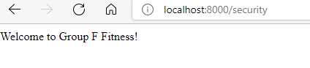

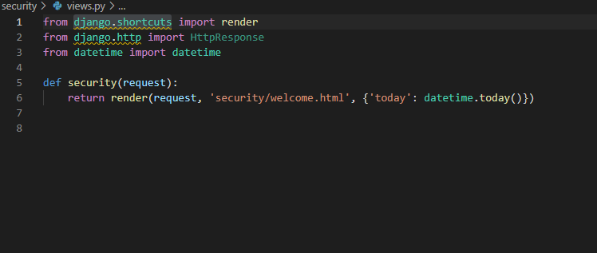

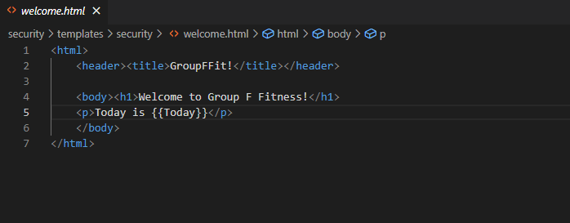

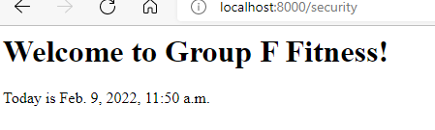

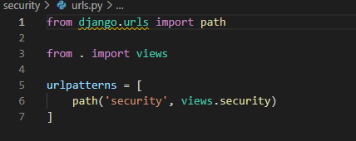

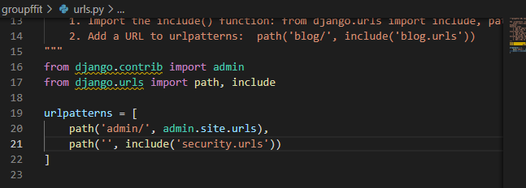

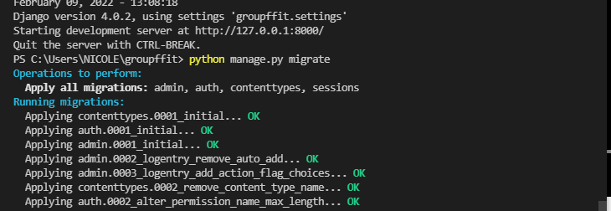

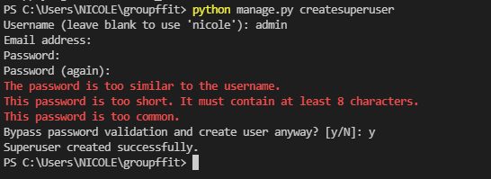

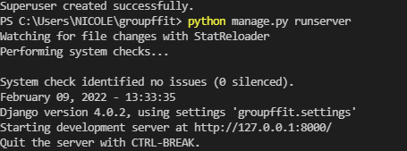

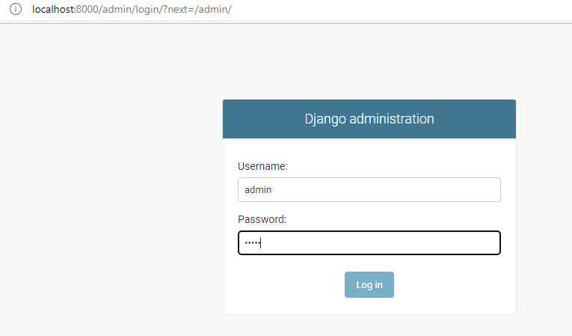

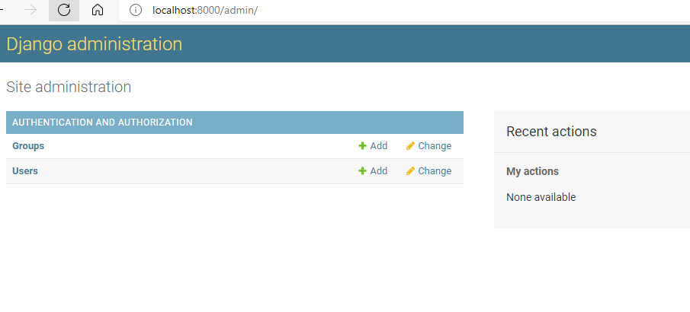

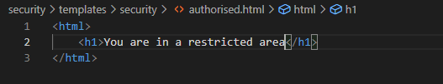

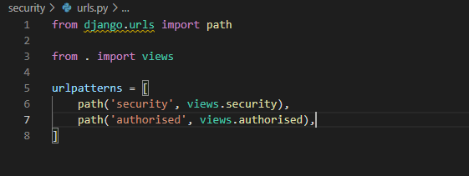

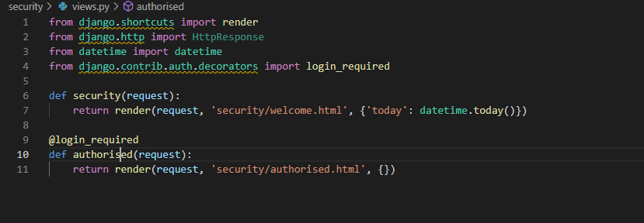

This produces a 404 error so add a command to direct to admin login when not logged in

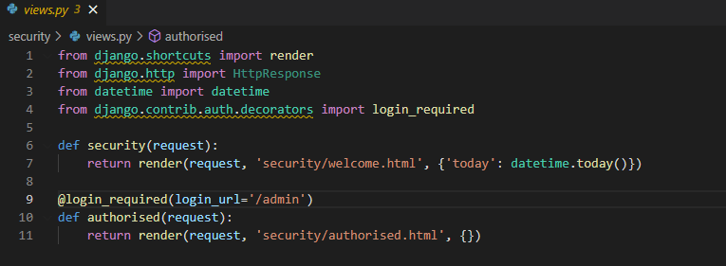

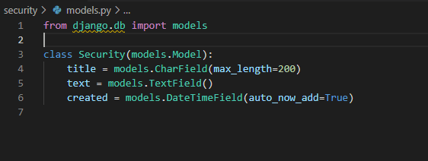

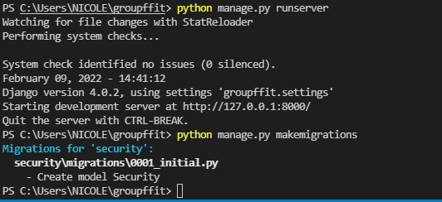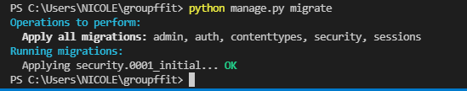

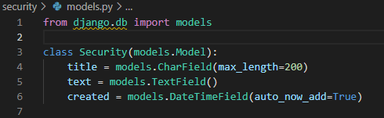

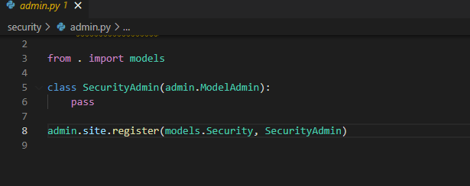

python manage.py runserver

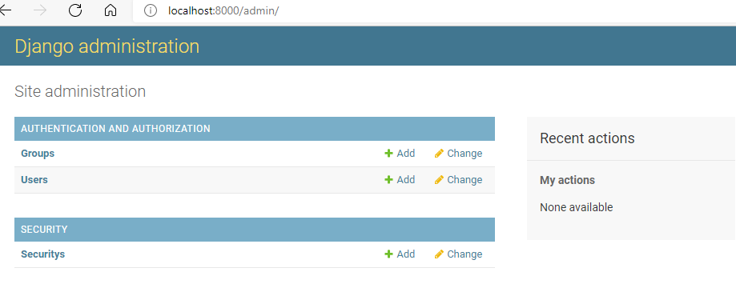

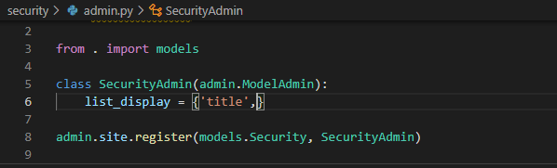

Change the pass to a tuple to provide a meaningful name for any data added to the Securitys model